**Excel Comparer Tool Guide Line**

1. Choose the excel file to compare.

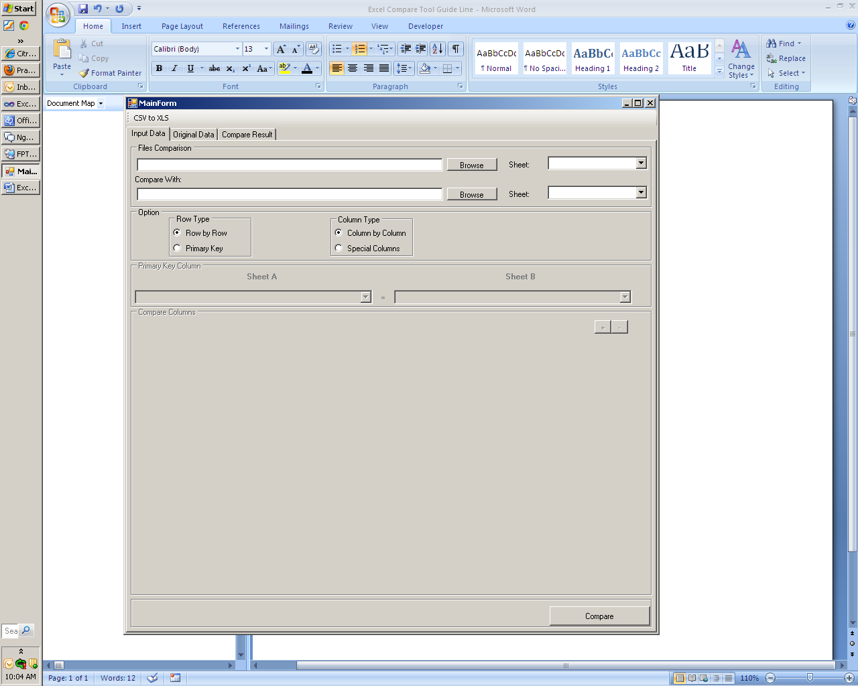

You can compare 2 sheets in the same excel file.

1. Comparison Optional



* Row type:
  + Row by row: compare data of 2 sheets have the same row numbers. Tool will be comparing each row in sheet corresponding with other one.
  + Primary key: compare data base on primary key values. When choice this case should specify the primary key column in below.
* Column type:
  + Column by column: compare data of 2 sheets have the same column numbers. Tool will be comparing each column in sheet corresponding with other one.
  + Special Column: compare data base on corresponded columns list. When choice this case should specifies the corresponding for each column in below.

1. Specifies Row and Columns:

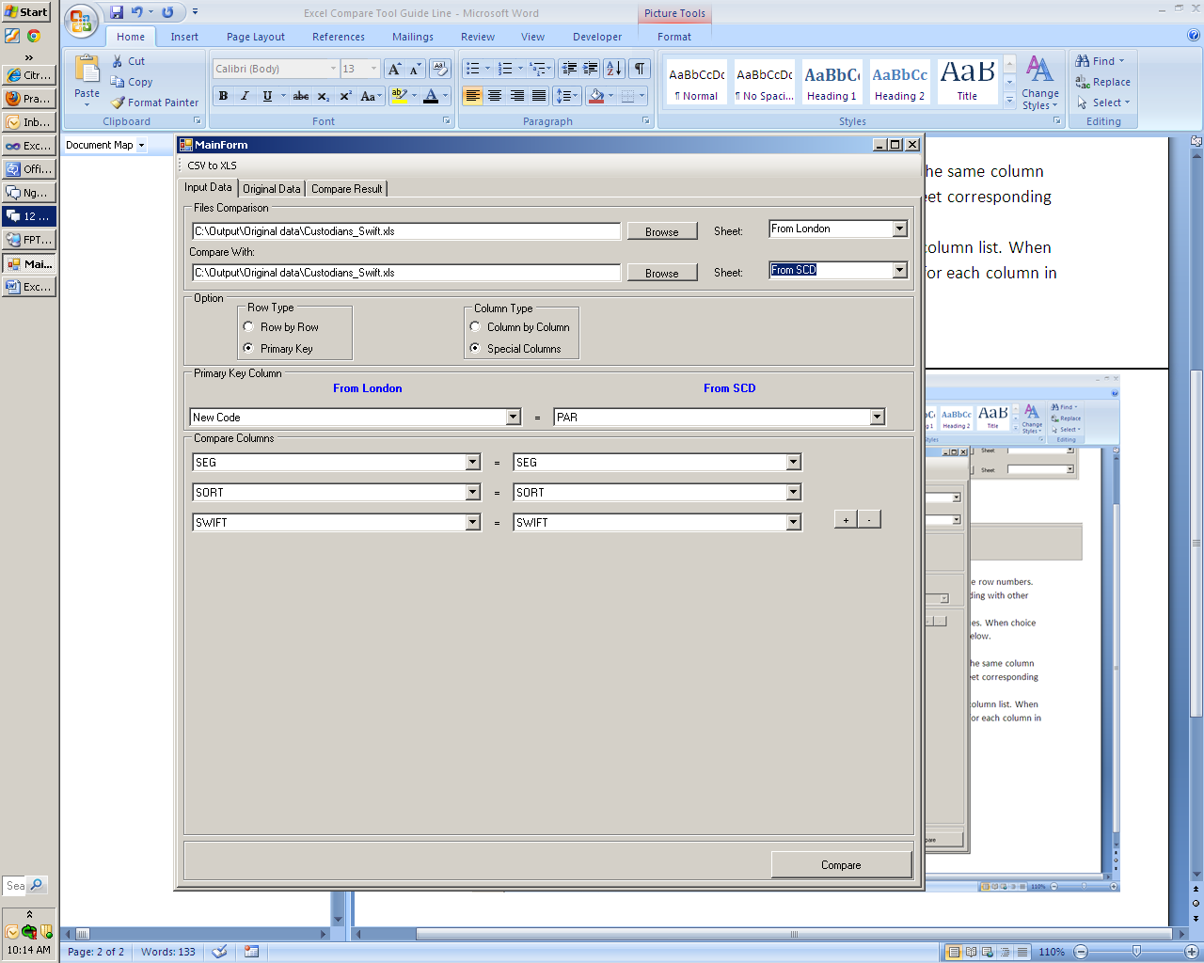

* Primary key column: define the primary key column for row comparison type is primary key.
* Compare Columns: define the corresponded columns list for column comparison type is Special columns.

Click button + to add more and button – to remove the column.

1. Compare data:

After complete the comparison configuration then click Compare button in bottom to perform the compare data.

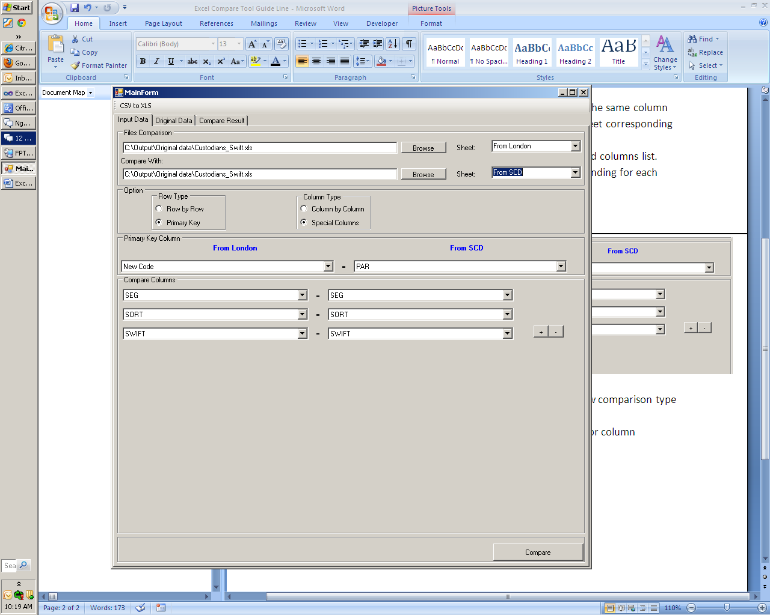

1. The Original Data Tab

In there will be displayed fully data of 2 sheets from excel files.

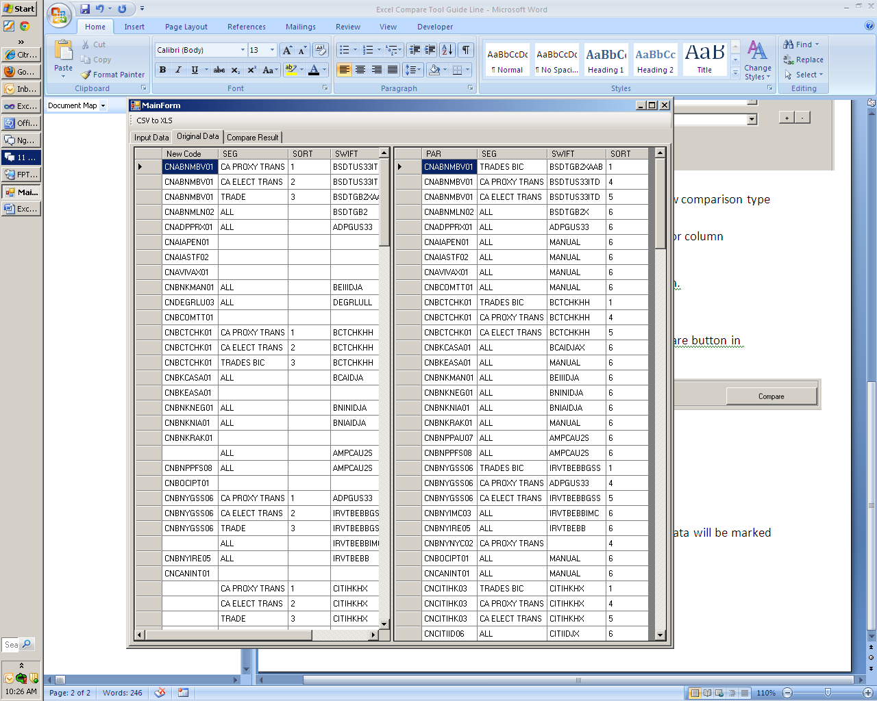

1. Compare Result Tab

In there will be displayed the compare result. The difference data will be marked by yellow background.

You can export the result to excel file by click export button in top.

